**ASSIGNMENT 9**

Demonstrate data transmission using FTP and HTTP protocols and analyse the network traffic through Wireshark or tcpdump

**FTP**

**Terminal commands**

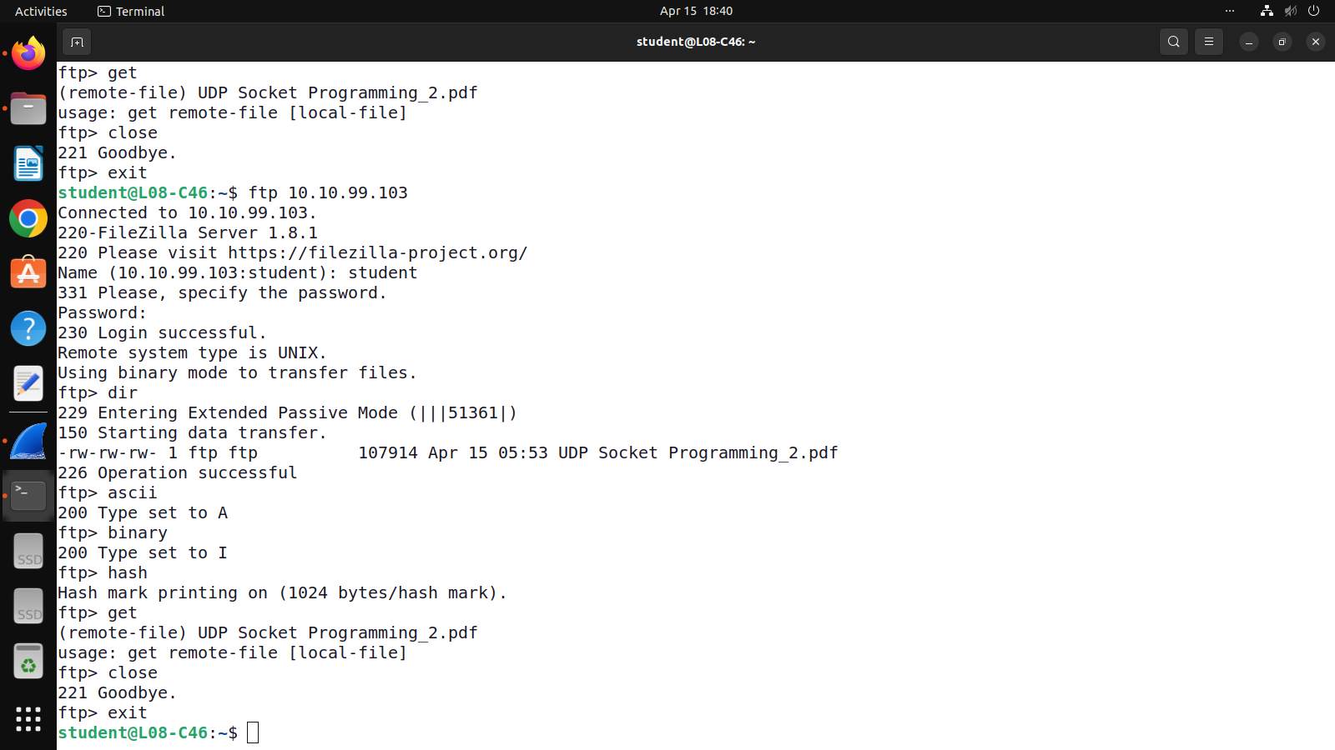

**Tcpdump for FTP**

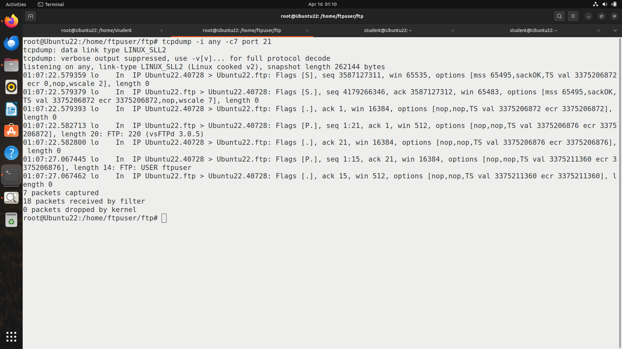

**Wireshark for FTP**

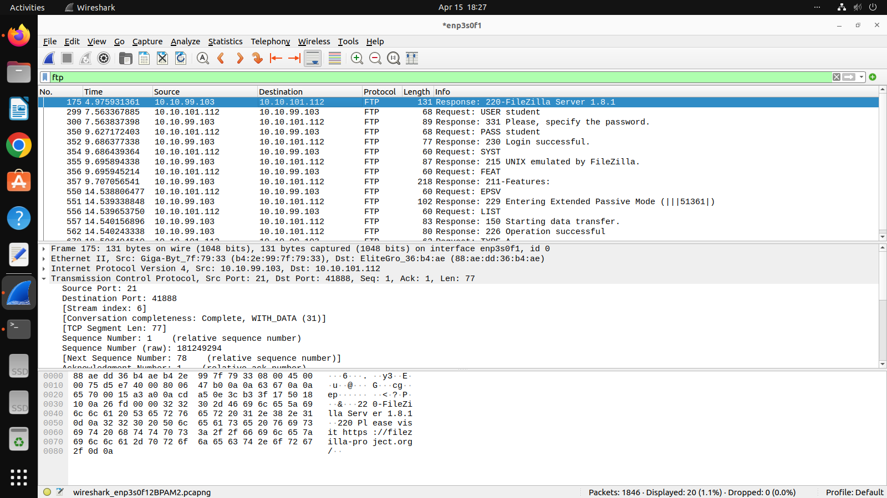

**HTTP**

**Tcpdump for HTTP**

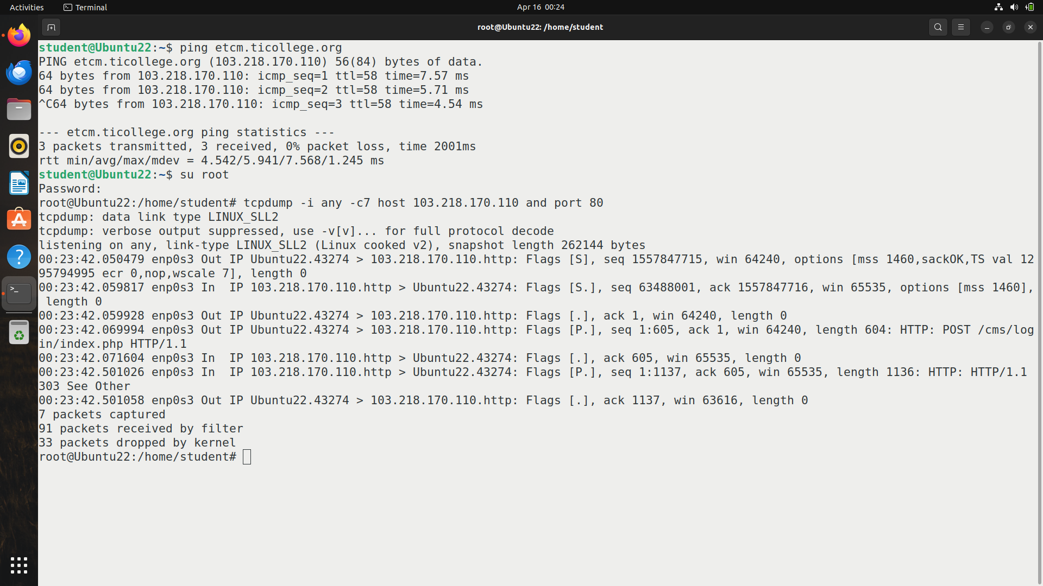

**Wireshark for HTTP**

